**SE 102.3 – Web Based Application Development**

**Tutorial**

1. Write down the HTML codes required to create the following form

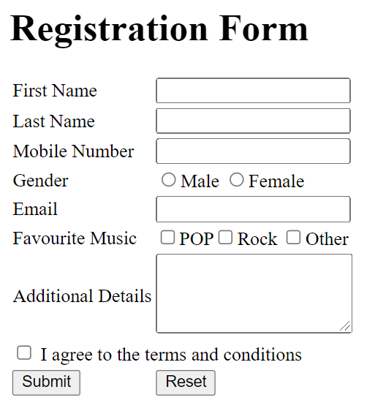

<html>

<head><title>Tutorials </title>

</head>

<body>

<table>

<form>

<caption><h1>Registration Form</h1><caption>

<tr><td>First Name</td><td> <input type="text" name="name"></td></tr>

<tr><td>Last Name</td><td> <input type="text" name="last"></td></tr>

<tr><td>Mobile number</td><td> <input type="phone number"></td></tr>

<tr><td>Gender</td><td> <input type="radio">Male <input type="radio">Female</td></tr>

<tr><td>Email</td><td><input type="email" id="email" name="email"></td></tr>

<tr><td>Favourite Music</td><td> <input type="checkbox">POP

<input type="checkbox">Rock

<input type="checkbox">Other</td></tr>

<tr><td>Additional Details</td><td><textarea rows="3" cols="25"></textarea></td></tr>

<tr><td><input type="checkbox">I agree to the terms and conditions</td></tr>

<tr><td><input type="submit" value="submit"></td>

<td><input type="reset" value="Reset"></td></tr>

</form>

</body>

</html>

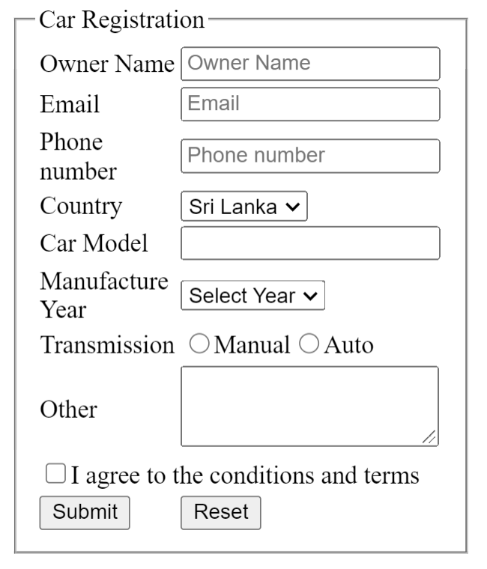

<html>

<head><title>Tutorials </title>

</head>

<body>

<fieldset>

<legend>car registration</legend>

<table>

<form>

<tr><td>Owner Name</td><td> <input type="text" name="name" placeholder="Owner Name"></td></tr>

<tr><td>Email</td><td><input type="email" id="email" name="email" placeholder="Email"></td></tr>

<tr><td>phone number</td><td> <input type="phone number" placeholder="Phone Number"></td></tr>

<tr><td>Country</td><td><select name="Sri Lanka">

<option>sri lanka</option>

<option>India</option></select></td></tr>

<tr><td>Car Model</td><td> <input type="text" name="car"></td></tr>

<tr><td>Manufacture Year</td><td><select name="Select Year">

<option>2023</option>

<option>2022</option></select></td></tr>

<tr><td>Transmission</td><td> <input type="radio">Manual <input type="radio">Auto</td></tr>

<tr><td>Other</td><td><textarea rows="3" cols="25"></textarea></td></tr>

<tr><td><input type="checkbox">I agree to the </td><td>terms and conditions</td></tr>

<tr><td><input type="submit" value="submit"></td>

<td><input type="reset" value="Reset"></td></tr>

</form></table></fieldset>

</body>

</html>